**Exemplar: Adding an aggregation**

**Overview**

In the exercise *Creating an aggregation*, you were asked to create and manage an aggregation in Power Query editor to reduce the data size of the **Fact** table and optimize query performance.

Your tasks in the exercise include:

* Create an aggregation based on the Fact table (**Sales** table) according to the required granularity.
* Configuring the data types of the aggregated columns and the source columns.
* Manage the aggregation in Power BI desktop.

This reading provides you with a step-by-step guide for completing these tasks. It also includes screenshots that you can compare against your work.

You can also review the [*Creating an aggregation*](https://www.coursera.org/learn/data-modeling-in-power-bi/lecture/6BHay/creating-an-aggregation)and [*Managing* *aggregations*](https://www.coursera.org/learn/data-modeling-in-power-bi/supplement/bZTJ6/managing-aggregations)videos.

**Step 1: Download the Adventure Works Power BI project.**

1. Download and save the file **Adventure Works.pbix***.*Load the data from the workbook into Power BI. Select the **Preview** pane to open a table preview. The data model has three tables of data:

* **Date**
* **Products**
* And **Sales**,

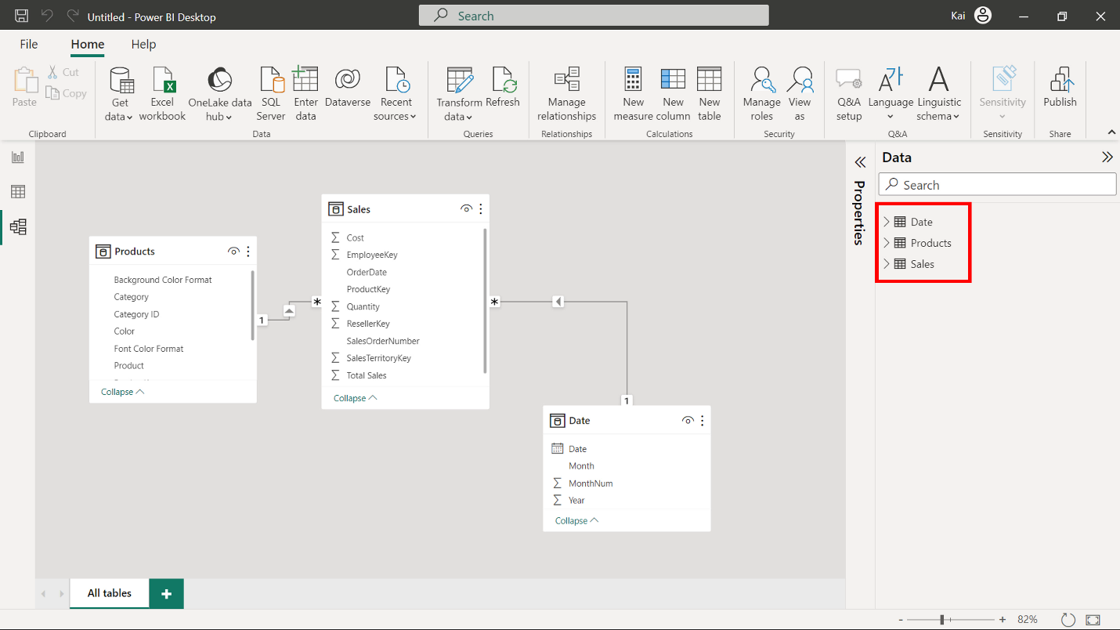

**Step 2: Create an aggregated table named SalesAgg**

1. On the **Home** tab, select**Transform data** and then **Transform data** from the drop-down menu.

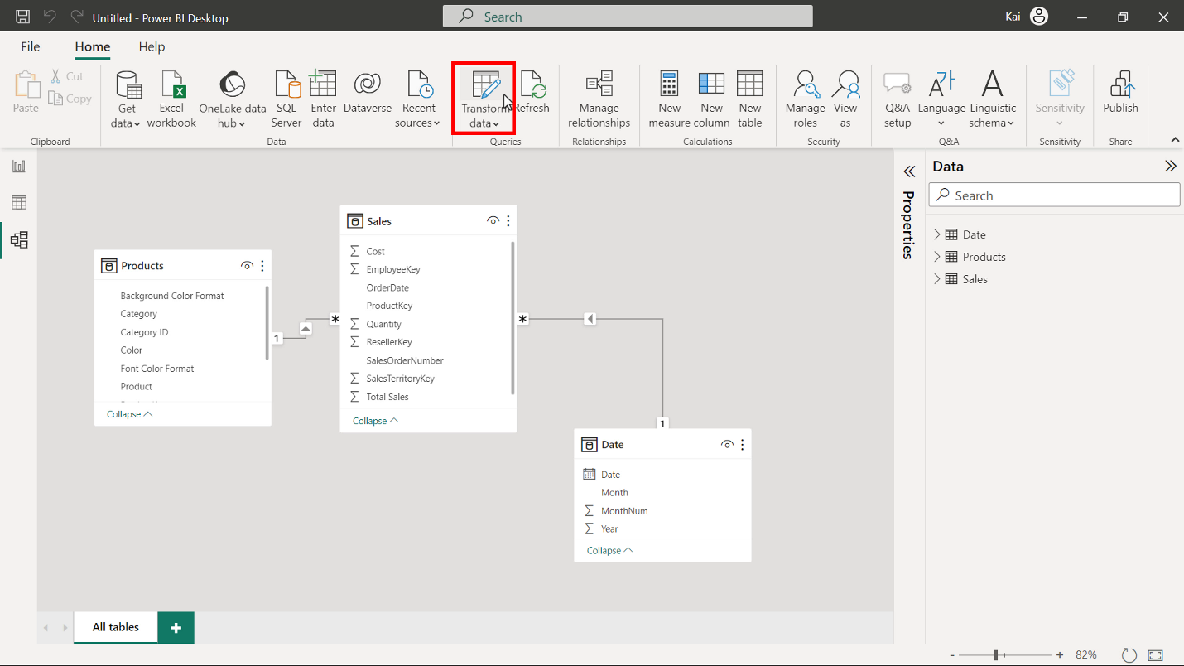

1. In the **Power Query** editor window, select the **Sales** table from the **Queries** pane on the left and right-click to open the context menu. Select **Reference** to duplicate the table. Use right-click again to re-open the menu.

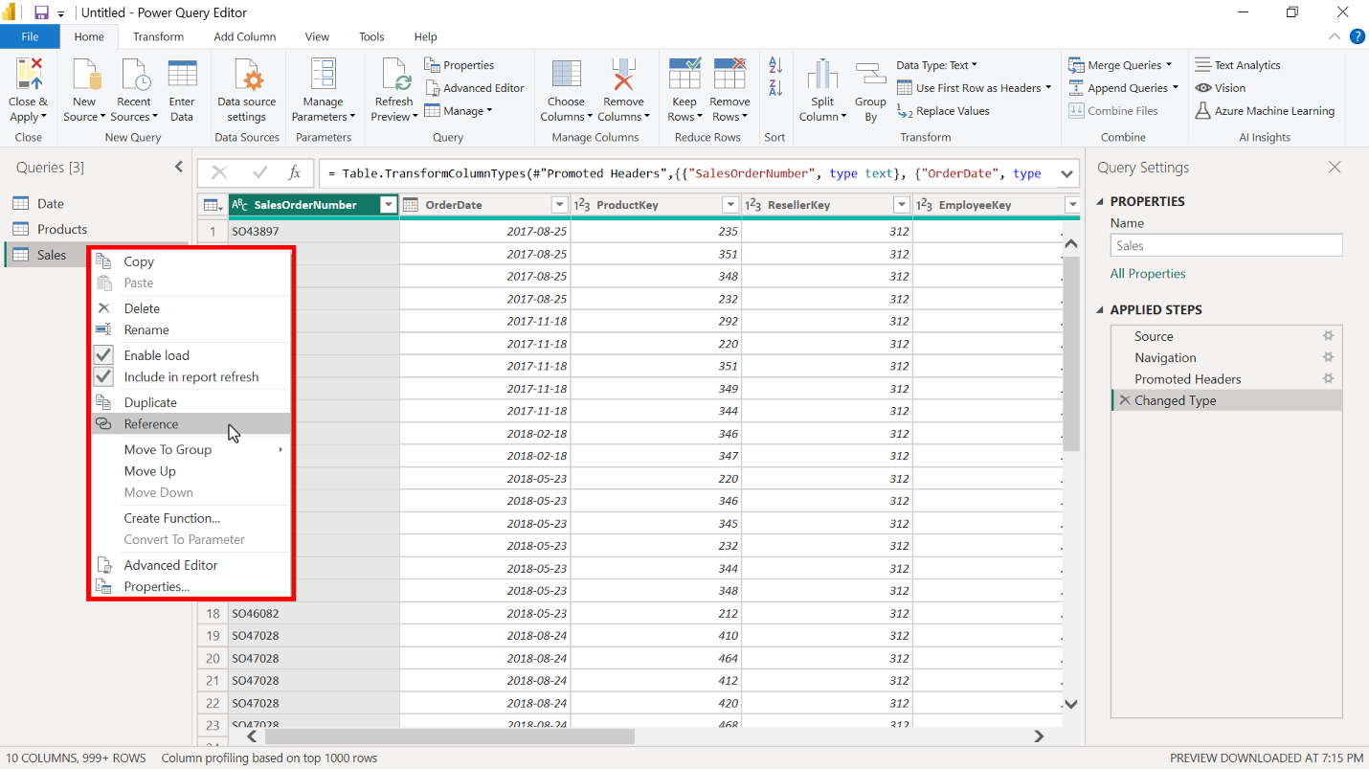

1. In the **Rename** field, rename the new table to **SalesAgg.** Duplications save the original tables for other analytics needs. So always copy the source table and create an aggregate from the duplicate copy.

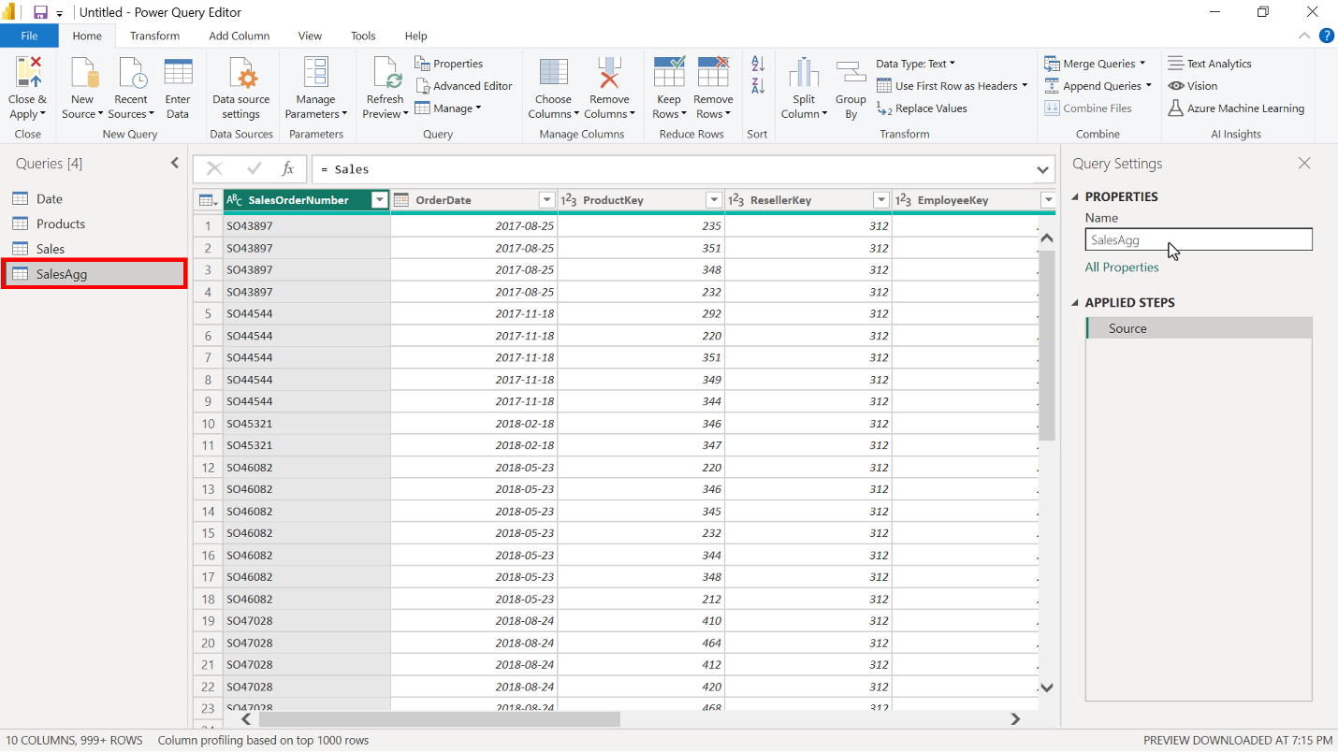

1. Choose the columns that you want to keep in the aggregated table from the source table by selecting the **Choose column** option on the **Home** tab in the **Power Query** editor window.

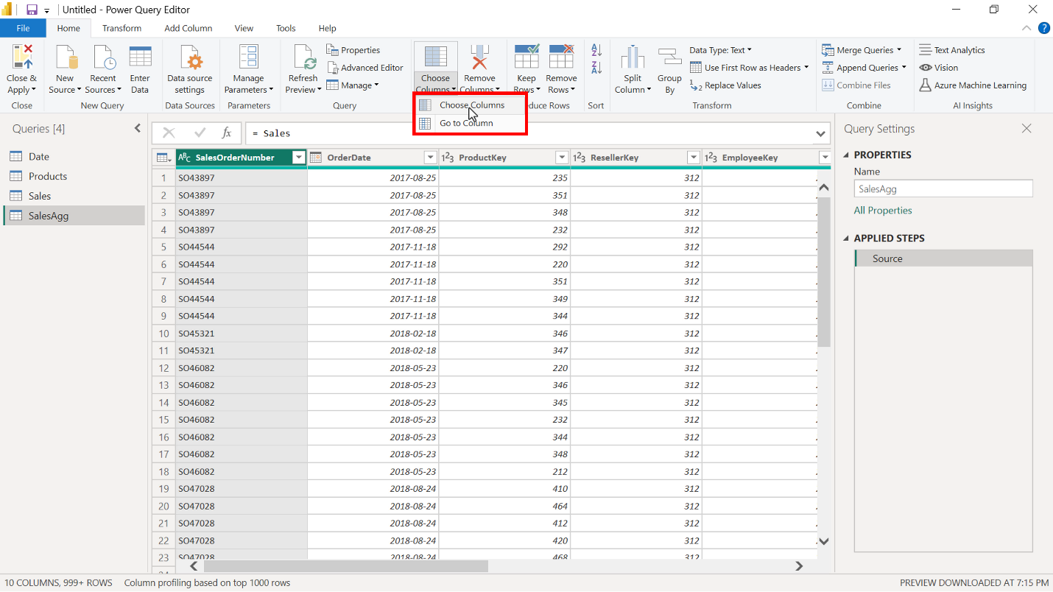

1. In the **Choose column** window select the following columns:

* **OrderDate** (This column is added to group data and will be used for the group by step)
* **Total Sales**
* **Quantity**
* **Cost**

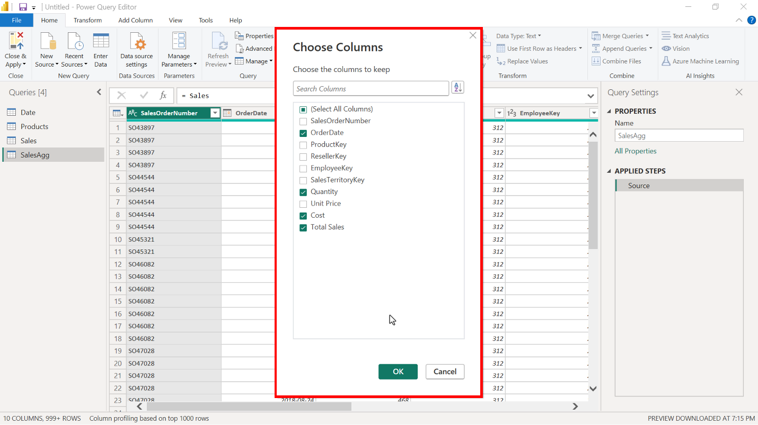

1. Next, select the **Transform** tab in the **Power Query** editor window and then **Group by**. This opens the **Group by** window, where you can define aggregate columns and mathematical operations to compute the aggregation.

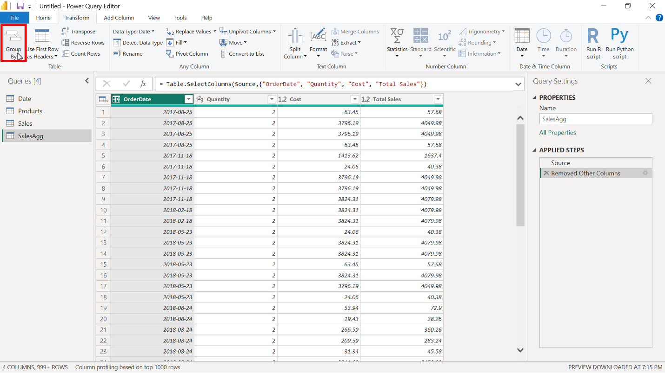

1. Group the aggregation by the **OrderDate** field in the **Group by** window.

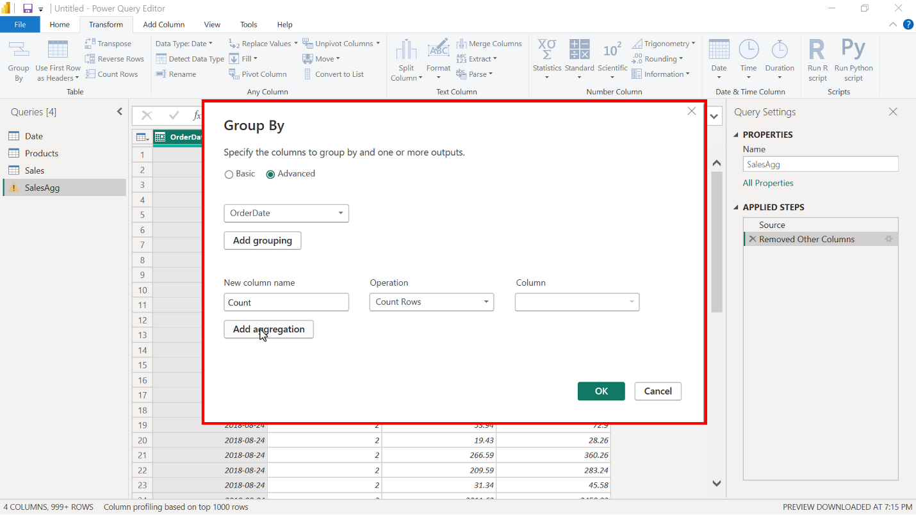

1. Create the following aggregate columns in the **Group by** window:

* **TotalQuantityCount** that uses the **Count** function as an operation.
* **SumTotalSales**, which performs a **Sum** as a mathematical operation and uses **Total Sales** as the column reference.
* **SumCost** also uses the **Sum** function and **Cost** as the column reference.

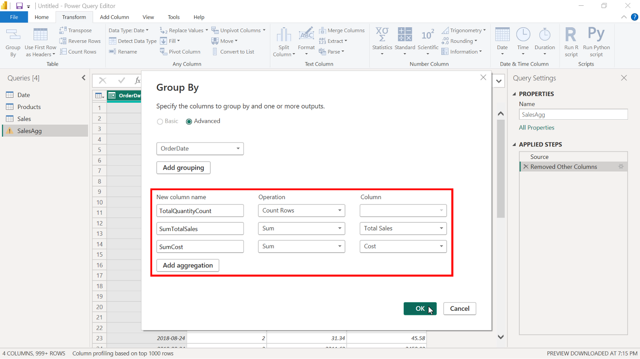

1. Select **OK** to apply all changes to the aggregation.

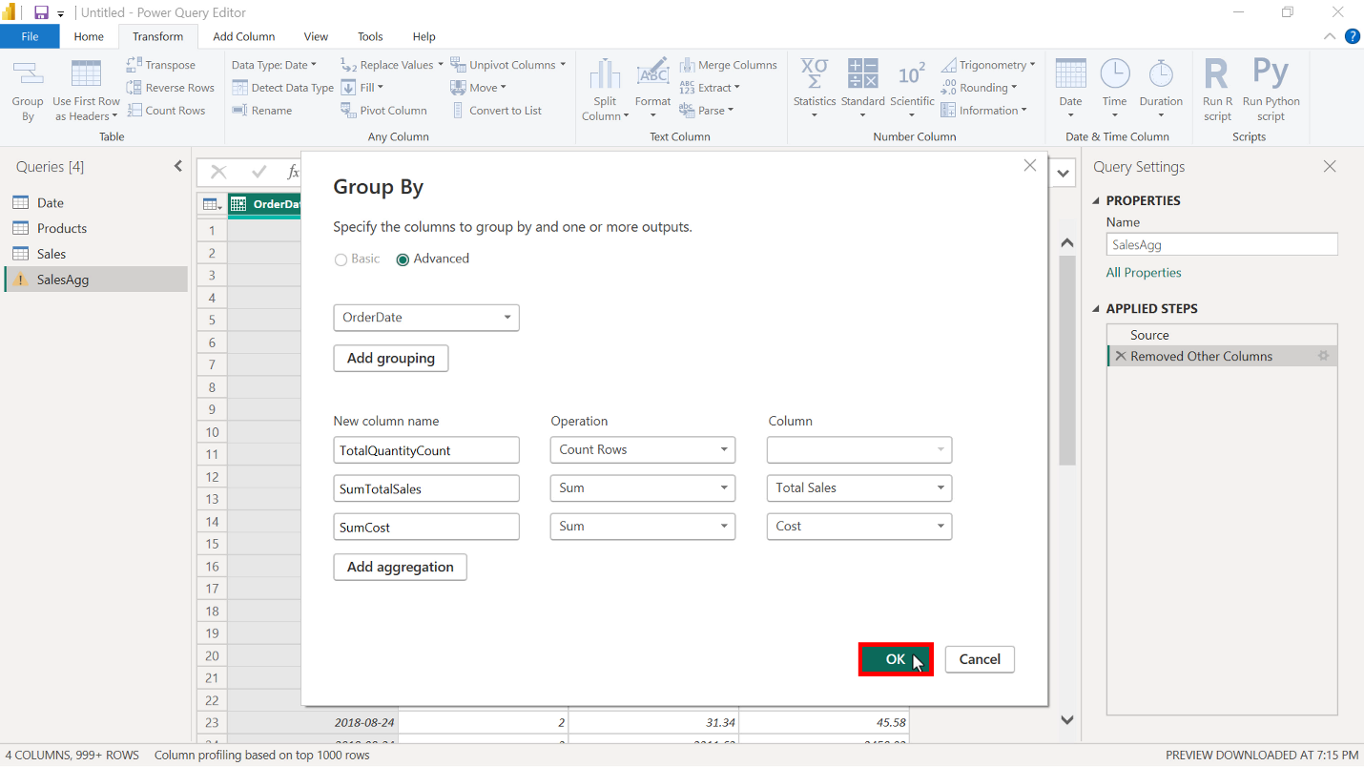

1. Select **Close and apply** on the **Home** tab to close the **Power Query** editor and return to the Microsoft Power BI desktop interface.

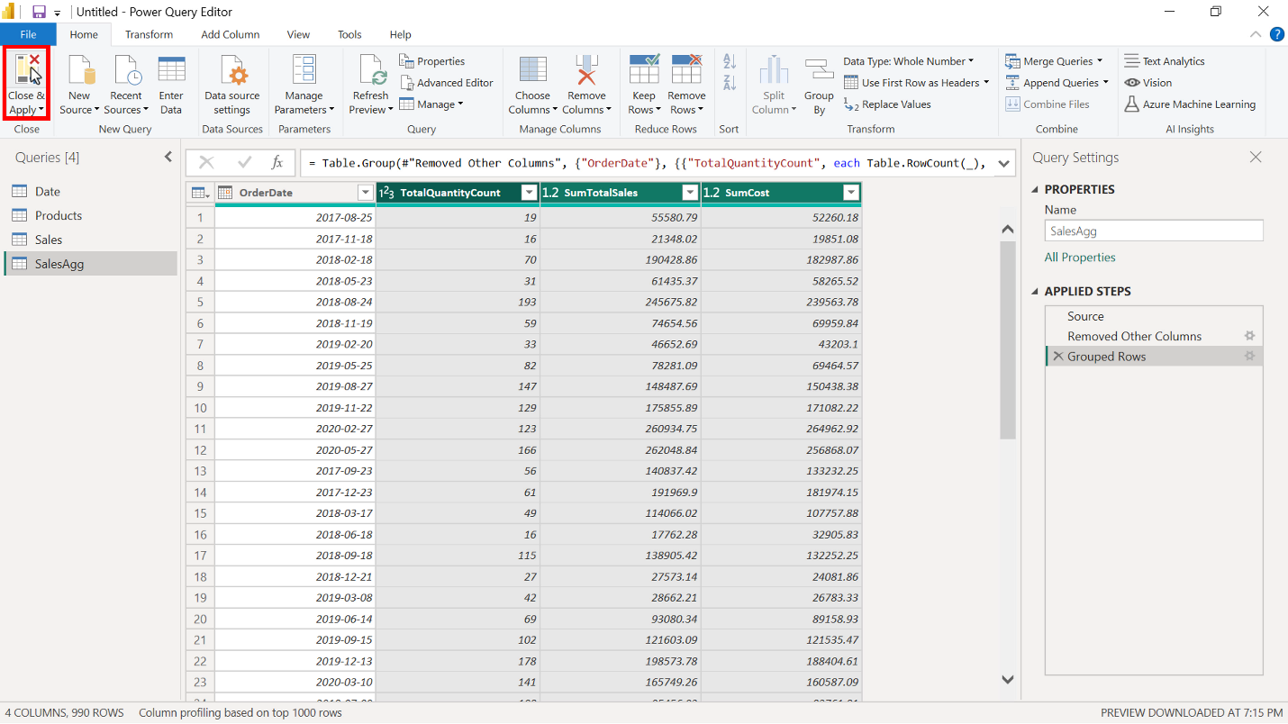

1. Select the table from the **Data** pane to display the total number of rows. In the **Sales** table, the number of rows is **57851**. The number of rows in the **SalesAgg** aggregated table is only **990**, which is 1.71% of the original rows, a significant reduction in data size.

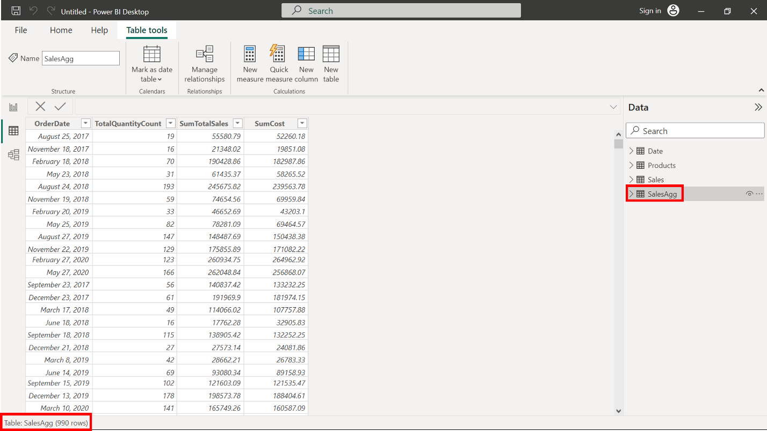

**Step 3: Establish relationship and manage aggregation in Power BI.**

1. The new aggregated **SalesAgg** Fact table does not have a relationship with the **Date** table. Switch to **Model view** and establish a relationship between the two tables based on the **OrderDate** field.

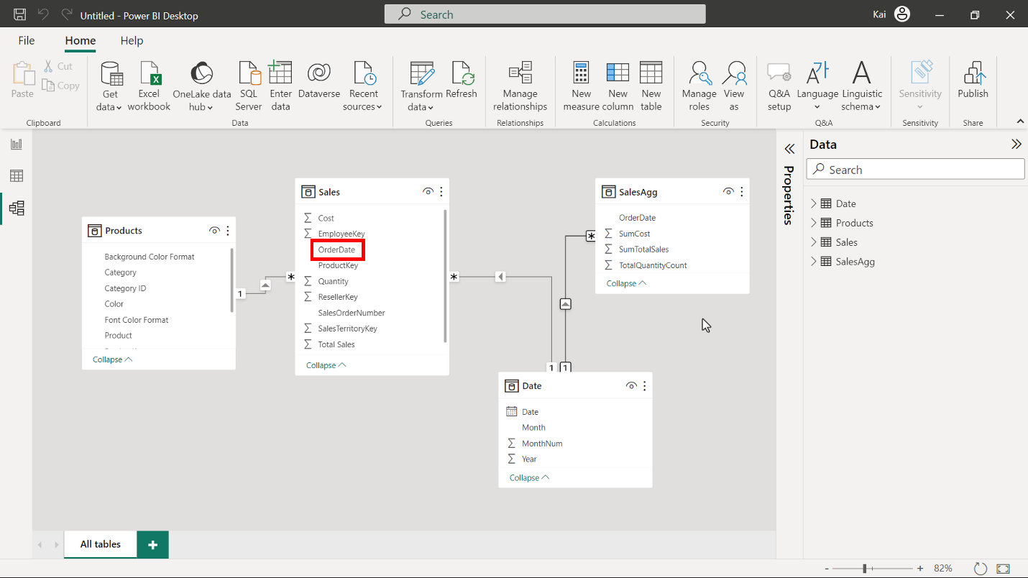

1. Open the **Power Query** editor again to ensure that the data types of the aggregate columns match the data types of the source columns as follows using the Data type icon to the left of each column:

* The data type of the column using **Count must** be set to **Whole number**.
* The data type of **SumTotalSales** and **SumCost** must be **Fixed decimal number**.

You can change the data type by selecting the **Data type** icon on the left side of the column name in the Power Query editor. Once you have completed the data type configuration, select **Close and apply** to return to Power BI desktop interface.

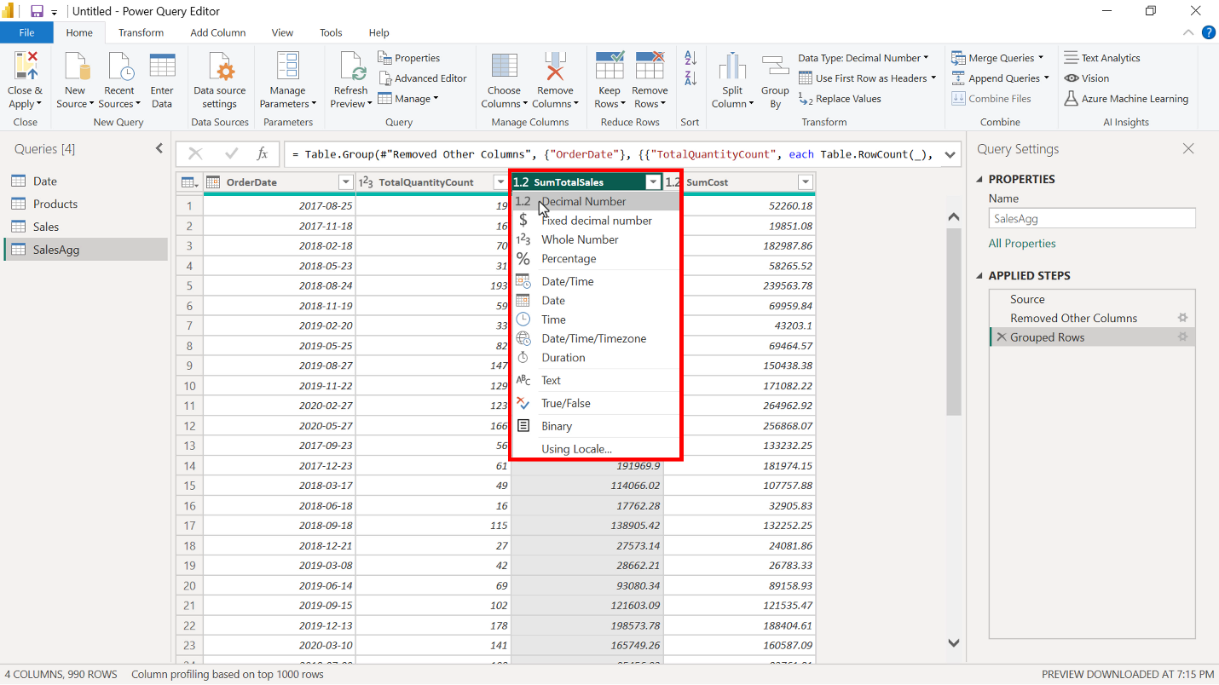

**Step 4: Save the Power BI project.**

* Save the Power BI project to your local computer.

To save the project, open the **File** menu, select **Save As,** and provide an appropriate name for the project along with a path to the folder on your computer.

**Conclusion**

With these steps, you have successfully created and configured an aggregation within the data model of Microsoft Power BI to reduce the data size significantly. You are now in the situation to help Adventure Works optimize the query performance and enhance user experience while interacting with the reports and visualizations.